Conduit Blog Application

Design and Specification Document

Tartalom

User 3

JWT 3

Article 4

ArticleView 4

# User

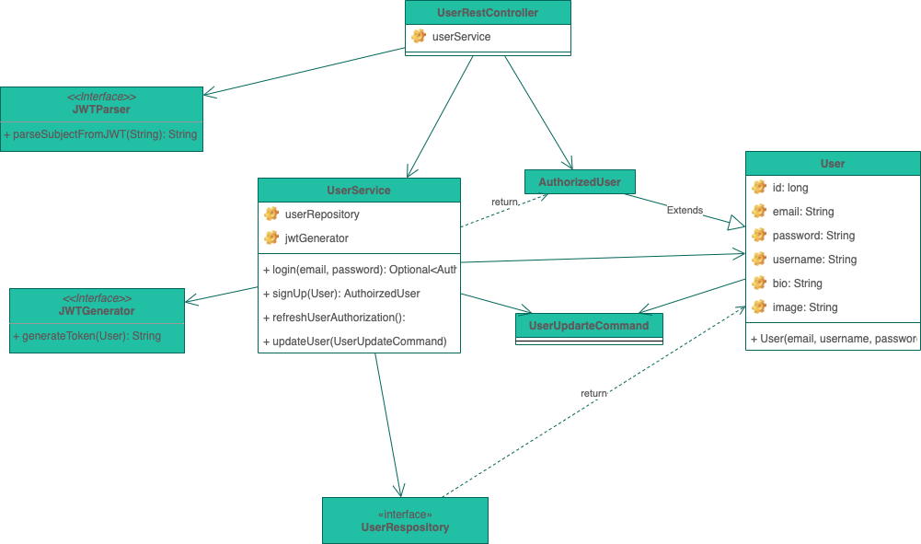

Separate interface for JWTGenerator and JWTParser

Try to do everything in UserService

# JWT

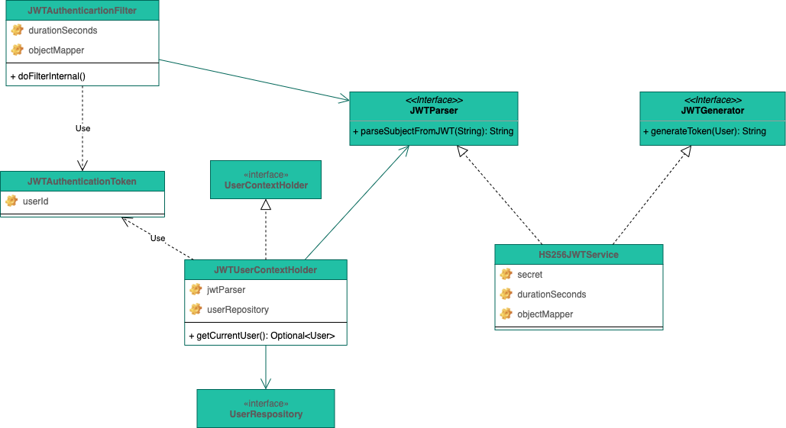

Try not to use 3rd party library

Context from JWT token can be retrieved using UserContextHolder implemtation

HS256JWTService do core logic

Symmetric JWT token signing using HS256 (includes Base64URL, SHA256)

Validate given token

# Article

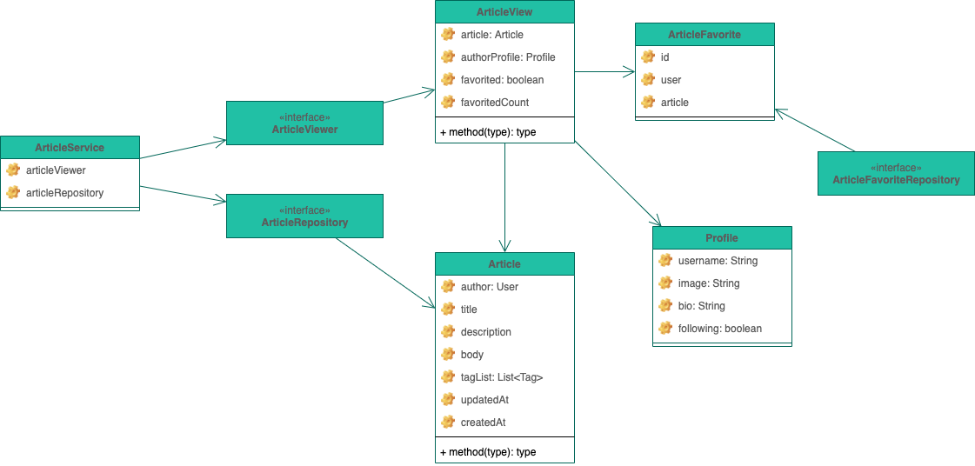

Separate @Entity with ArticleView class

Favorite of articles is another @Entity

# ArticleView

ArticleView contains run-time information about Article

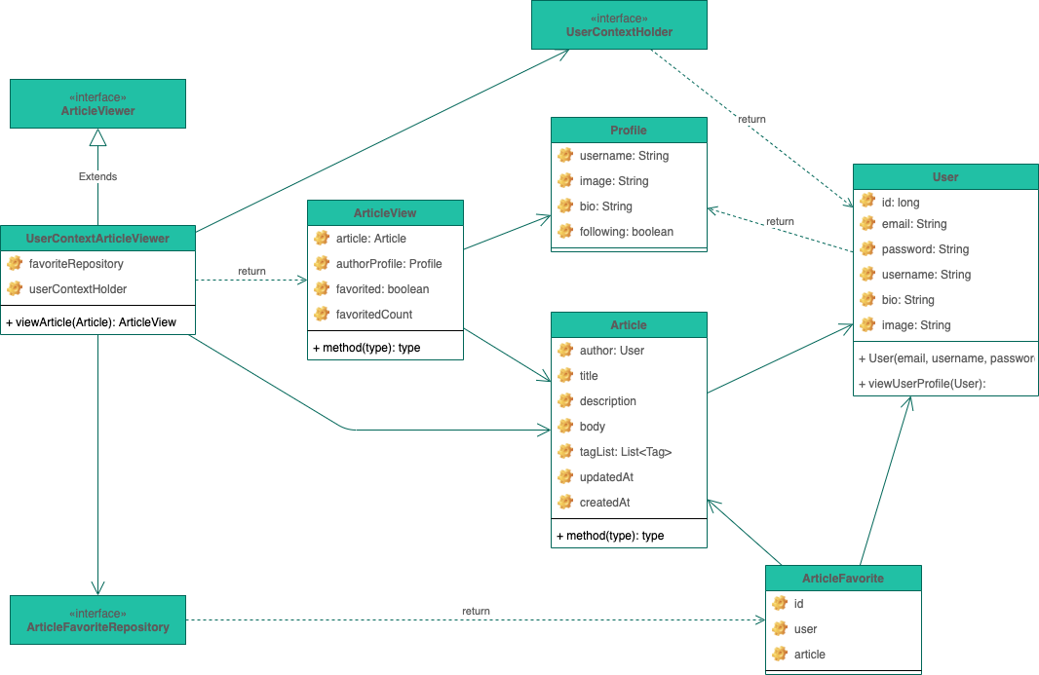

# Profile

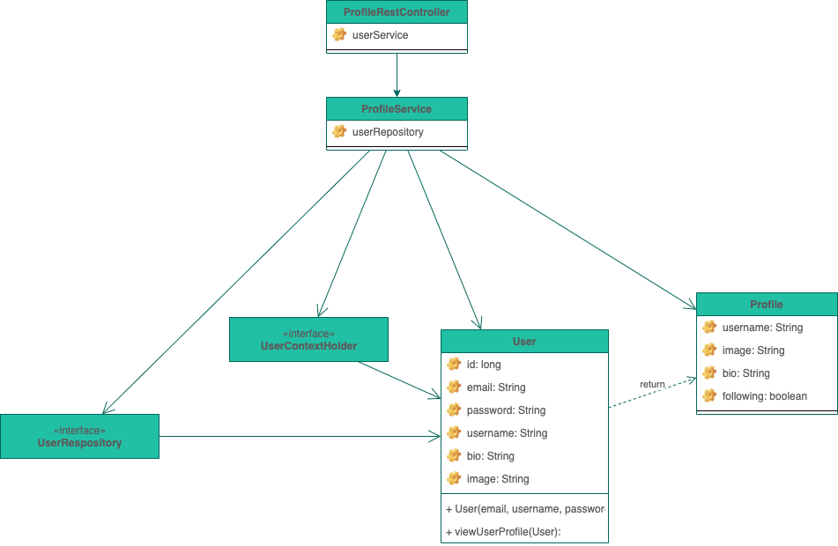

Profile as sperate service since it is used widely